Hydrogen-Deuterium Mass Ratio

*By: Alex Liechty, Crystal Nelson, Junhua Deng*

*Date: April 26, 2022-May 10, 2022*

## Theory Exercises (AL, CN, JD 4/26/2022-4/28/2022)

## In order to estimate the expected value for the wavelength difference in alpha lines, assuming a mass ratio of 1:2, the equation below was used:

The alpha line is known to occur at 6563 A, and the value of MH/m = 1836.15 is well established. Plugging in these values gave ΔλHD = (0.5)(6563) / 1836.15 = 1.786 A.

The expected wavelength difference of the sodium D lines is ΔλNa = 5895.92 - 5889.95 = 5.97 A.

The gives the estimated ratio ΔλHD / ΔλNa = 0.3

In order to place the sodium D lines 8 divisions apart with 4 sec/div, for a separation of 32s by using the stepper motor, first find the number of revolutions needed to span the 6 angstrom difference between the sodium D lines.

The wavelength knob covers 20 angstroms in 1 revolution, so 6 A / 20 A = 0.3 revolutions. Taking the gear ratio of 1:36 into account, this means there needs to be 0.3 * 36 = 10.8 revolutions of the stepper motor.

We want these 10.8 revolutions to happen over the course of 32 seconds, giving 10.8 / 32 = 0.337 rev/s.

Finally, since the stepper motor has 200 steps per rotation, the frequency desired is 0.337 * 200 = 67.5 s-1.

1. Calculate the wavelengths of the next three higher-energy lines in the Balmer series from Eq. (3). The given wavelengths are: 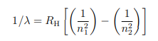

RH = 10967758.1m-1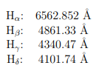

For the n = 7 to n = 2 transition, 1/λ = RH [(1/4)-(1/49)], giving λ = 3971.24**Å**

For the n = 8 to n = 2 transition, 1/λ = RH [(1/4)-(1/64)], giving λ = 3890.19**Å**

For the n = 9 to n = 2 transition, 1/λ = RH [(1/4)-(1/81)], giving λ = 3836.51**Å**

1. Prove the above claim about the image of the lamp by making a ray diagram.

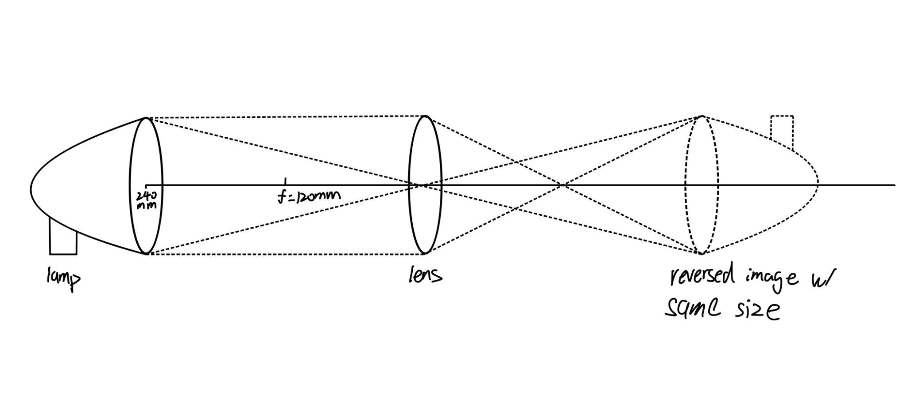

## Background & Setup (AL, CN, JD 4/28/2022-5/10/2022)

For this lab, we had to measure the sodium-D Balmer series lines and record them; then, we had to use the equipment to find the differences between the Hydrogen series lines and the Deuterium series lines. We found the Alpha, Beta, Gamma, Delta, and Epsilon lines at Peak 1 and Peak 2, and then color coded these line types in our analysis. These were then used to derive the ratio of their masses using the Rydberg constants for the isotopes (which allowed us to use the reduced masses for calculations).

We fit the data using two different methods: centroid fit and Gaussian fit. Both were run using Python for optimal precision and accuracy in our calculations.

Here is our diagram with connections shown (some elements are slightly shifted to show detail):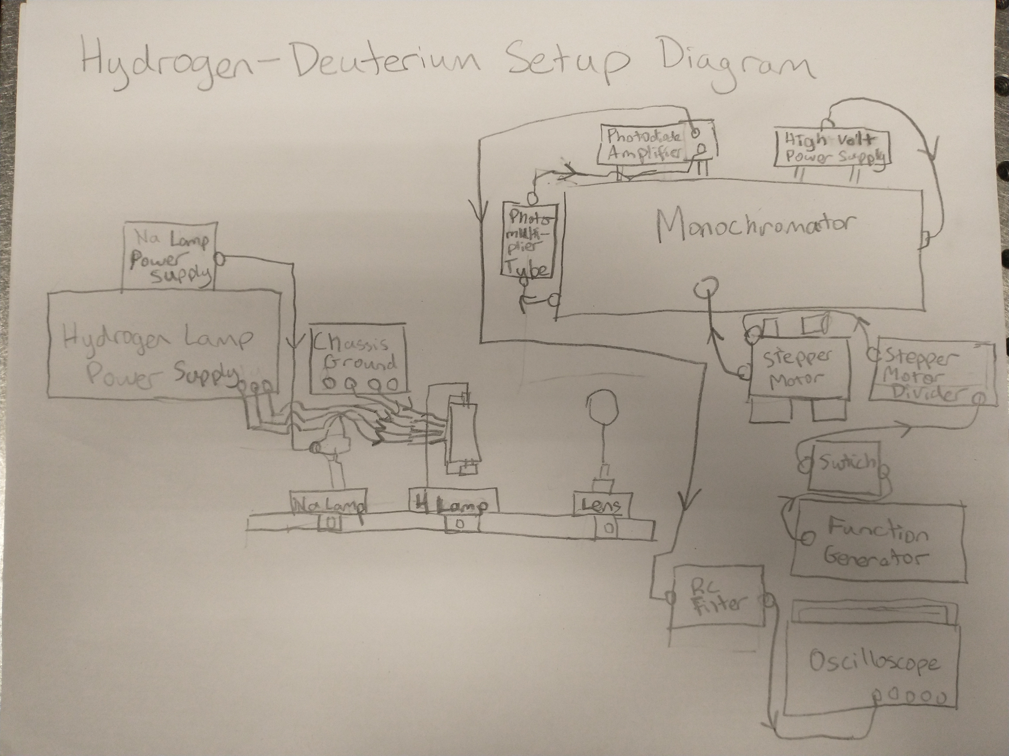

Here is a photo of the area: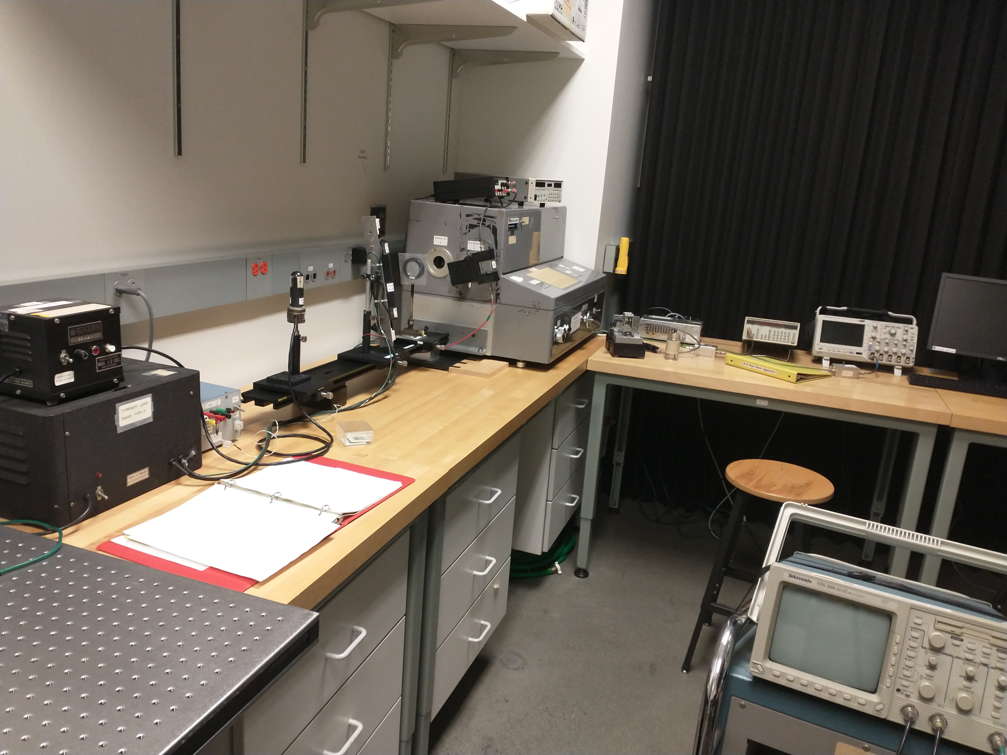

Our setup diagram shows all the connections between the machines that must be made to take the measurements for this lab

## Experiment Notes (AL, CN, JD 4/26/2022-4/28/2022)

Settings:

* 5890, 5896 Angstroms for sodium
* Microamps scale for PA700
* Scope scale: 4s horizontal, 200mV vertical
* Gain: as high as possible for epsilon peaks

When we changed the range on the PD-700 for the delta and epsilon measurements, we did not offset this originally. We corrected this in our data analysis by vertically shifting our data to adjust the vertical zero.

First we took calibration peaks of sodium and from our work in exercise one we drove the step motor with a frequency of 67.5 Hz in order to separate the sodium peaks by about 32 seconds or 8 divisions.

Here is a screenshot of the oscilloscope reading for sodium peaks**:

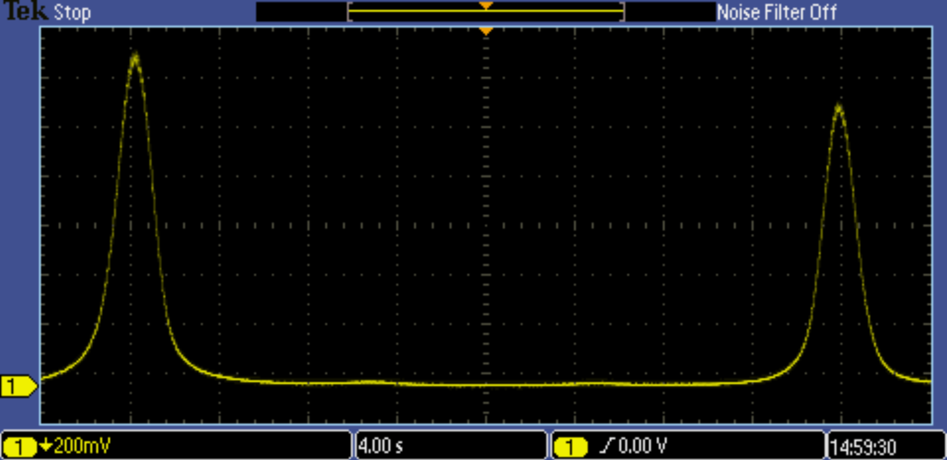

After taking the calibration measurement, we kept that same frequency and time scale and adjusted the wavelength of the monochromator was adjusted to be about an angstrom below the Hydrogen Blamer alpha line and the motor was run to see peaks from both the Hydrogen and Deuterium. This process was repeated for the Balmer beta, gamma, delta, and epsilon lines and our oscilloscope screens were:

Balmer Alpha lines** scale=50mV/div:

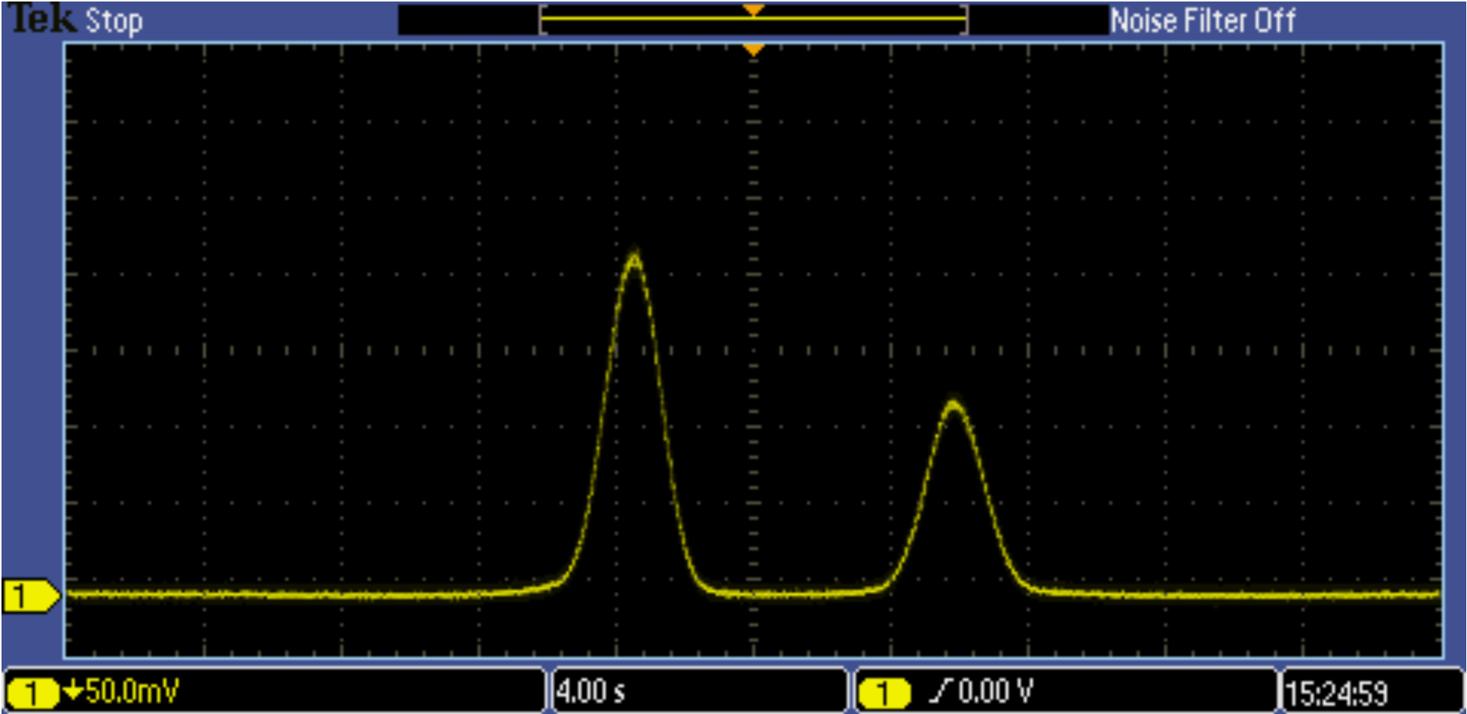

Balmer Beta lines** scale=100mV/div:

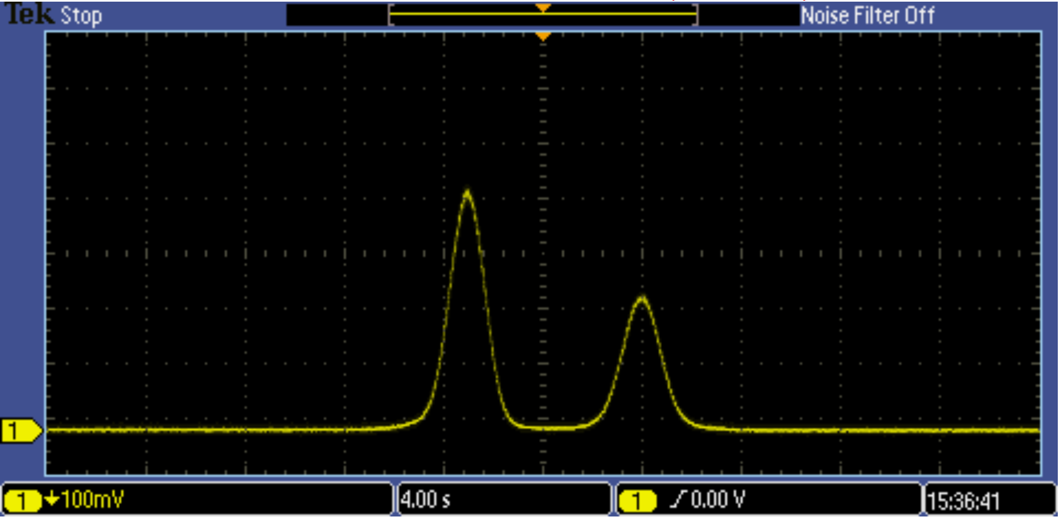

Balmer Gamma lines** scale scale=50mV/div:

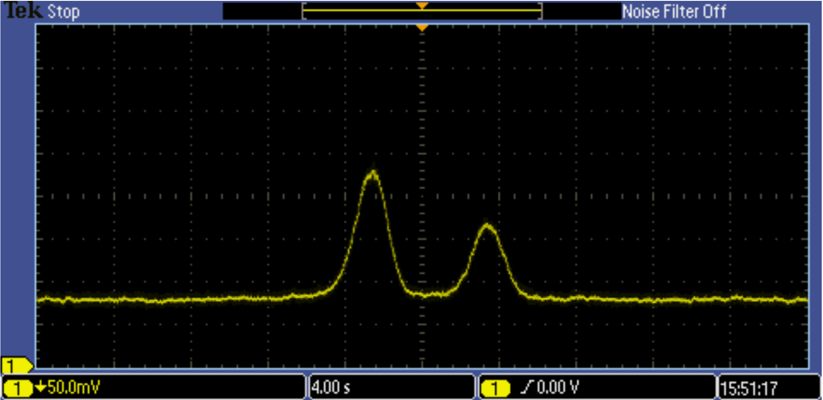

Balmer Delta lines** scale=50mV/div:



Balmer Epsilon Lines** - scale=5mV/div:

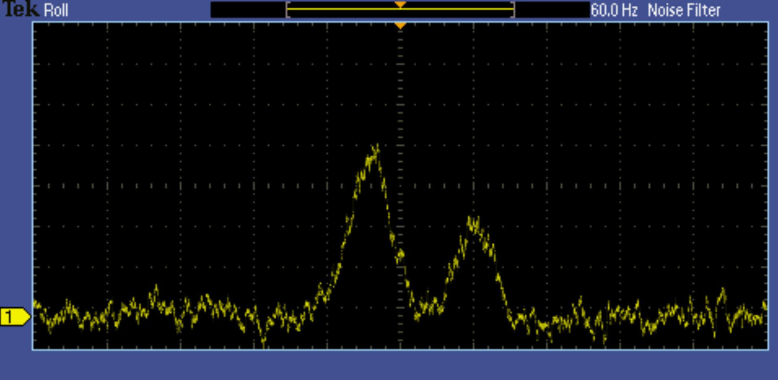

**FOR ALL GRAPHS, THE AXES ARE VOLTAGE (V) VERSUS TIME (s)

## Data reduction & Preliminary results (AL, CN, JD 4/26/2022)

From Exercise 1, our expected value for the wavelength difference between spectral lines of Hydrogen and Deuterium is 1.78 Angstroms.

Here is our data overlaid (after offset and scaling for readability):

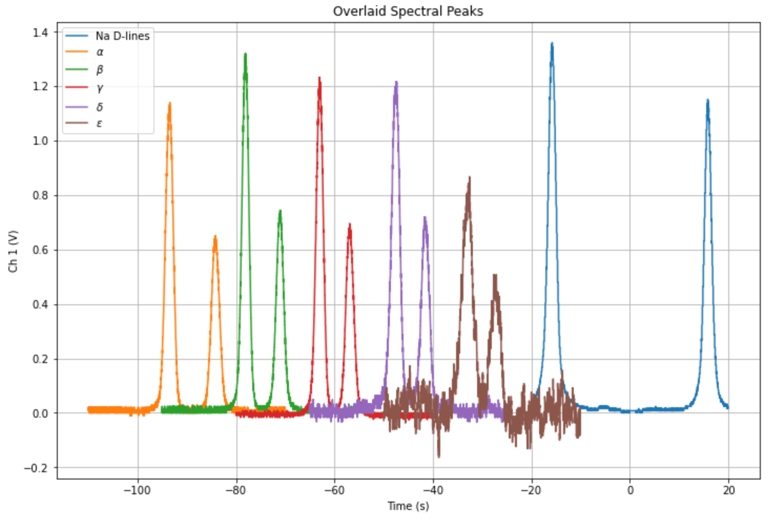

We used two different methods to analyze the peaks in our data. The first method we used was to find the centroid of each peak. Using this method we found the centroid locations to be:

|  |  |  |  |  |  |  |
| --- | --- | --- | --- | --- | --- | --- |
|  | Sodium D-Lines | Alpha | Beta | Gamma | Delta | Epsilon |
| Peak 1 Location (s) | -15.824  +/- 0.024 | -3.556  +/- 0.036 | -3.104  +/- 0.043 | -3.020  +/- 0.022 | -2.61  +/- 0.10 | -2.96  +/- 0.36 |
| Peak 2 Location (s) | 15.832  +/- 0.032 | 5.821  +/- 0.051 | 3.926  +/- 0.024 | 3.113  +/- 0.030 | 3.406  +/- 0.018 | 2.58  +/- 0.21 |

For the second method we fit the peaks to a Gaussian curve and found the mean of the associated fits. Using this method we found the peak locations to be:

|  |  |  |  |  |  |  |
| --- | --- | --- | --- | --- | --- | --- |
|  | Sodium D-Lines | Alpha | Beta | Gamma | Delta | Epsilon |
| Peak 1 Location (s) | -15.8207  +/- 0.0016 | -3.53685  +/- 0.00040 | -3.08845  +/- 0.00041 | -3.01940  +/- 0.00048 | -2.6667  +/- 0.0012 | -3.0126  +/- 0.0053 |
| Peak 2 Location (s) | 15.8462  +/- 0.0018 | 5.82072  +/- 0.00074 | 3.92527  +/- 0.00078 | 3.08974  +/- 0.00089 | 3.3567  +/- 0.0021 | 2.6660  +/- 0.0084 |

Our values were all in range of what we expected to see before putting the data in for Python analysis (graph shapes, peaks, etc) from the oscilloscope. Once we imported the data and increased the epsilon data by 40x in Python and readability was addressed using offsetting and scaling, the graphs showed all the peaks at appropriate wavelengths.

Both quantitatively and qualitatively, the data came out as expected, with the exception of some slight discrepancies from smooth Gaussian curves for the delta and epsilon peaks. (These were likely because noise became more of a factor in these later data sets due to the noise range becoming a larger percentage of the peak heights.) The large sample size of data from the automation of the graph transfer helped significantly with getting our data to appear with a relatively high degree of accuracy and precision, as instrumental error was much smaller than it would otherwise be.

## Final Analysis (AL, CN, JD 4/28/2022)

In order to use our measurements to determine the Hydrogen-Deuterium mass ratio, we use the peak positions and found their differences and used our sodium calibration to convert these differences to wavelength differences. We then fit a linear model to these differences and the slove gave us the wavelength difference over the hydrogen line wavelength, which we used the below equation to find the mass ratio: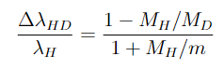

The equation can be rearranged:

And MH/m = 1836.15 is a well established value.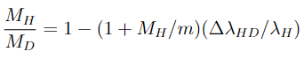

For the centroid method our linear fit was:

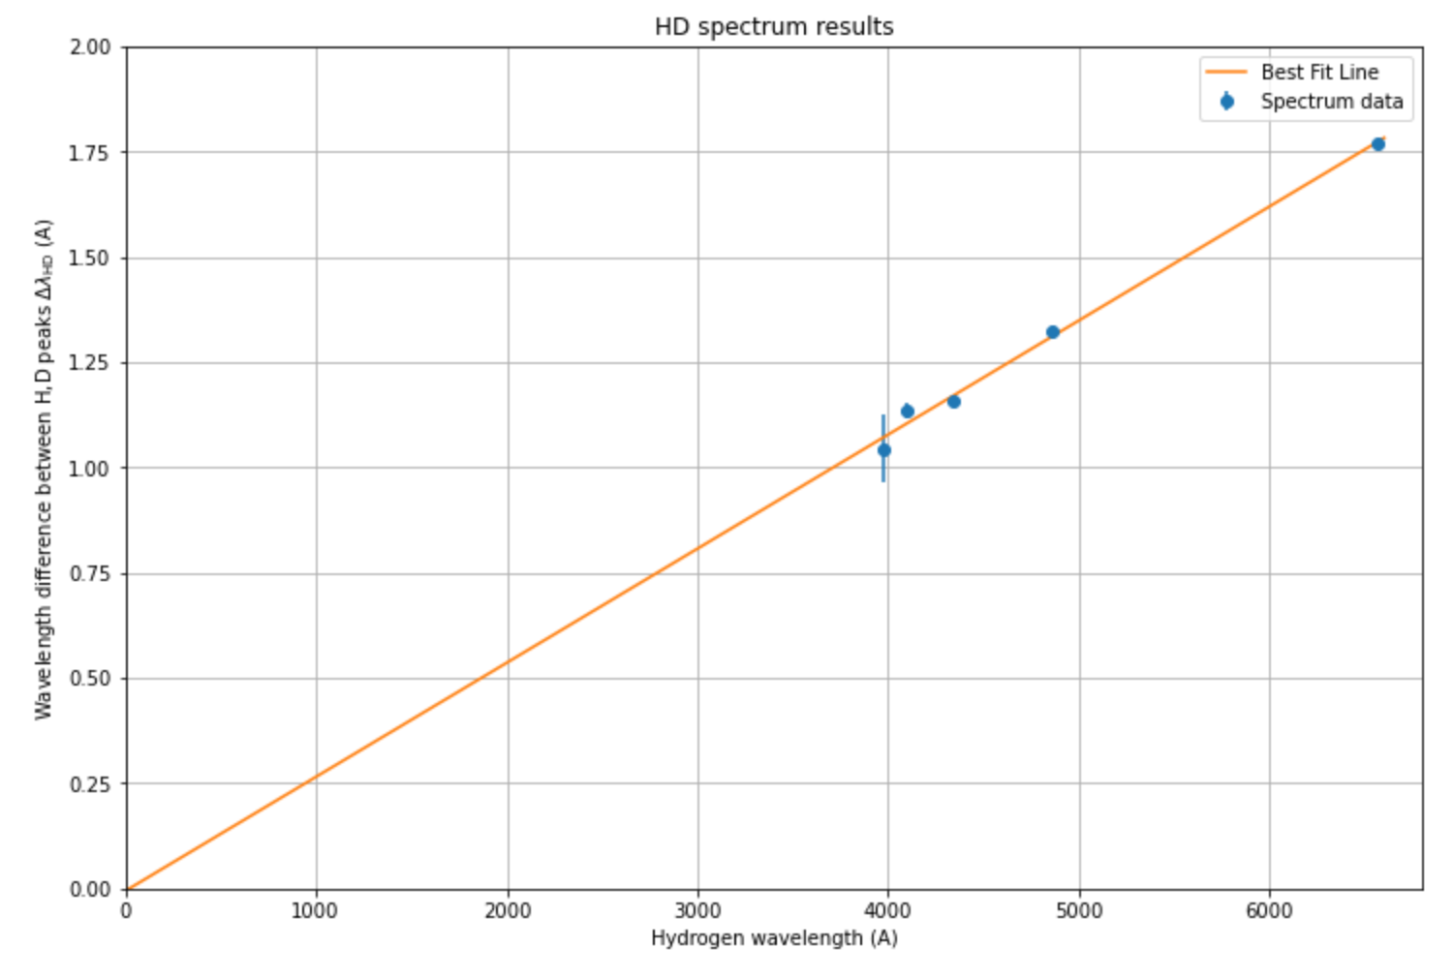

Using the slope of the linear fit gave a mass ratio of 0.502 +/- 0.0220.

The differences in peak locations were converted from time in seconds to wavelengths in angstroms using the known sodium calibration peak differences which gave a calibration constant of 0.18859 +/- 0.00024 A/s.

The uncertainties in the alpha, beta, and gamma lines cannot be seen because they are much smaller than the vertical scale and are small compared to the uncertainties in the delta and epsilon lines.

Using the Gaussian fit method our linear fit was:

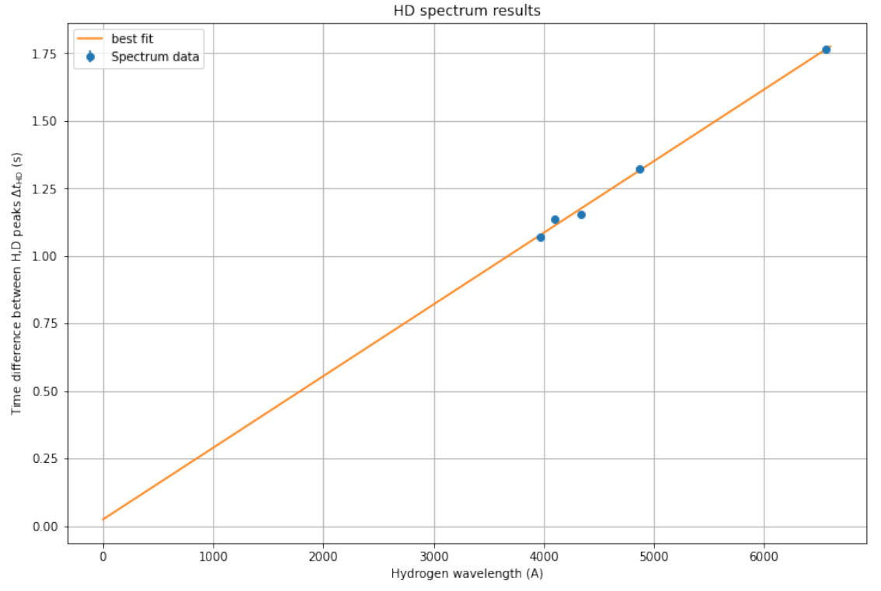

Using the slope of the linear model found with this method gave us a mass ratio of 0.51303 +/- 0.017494

The same calibration constant of 0.18859 +/ 0.00024 A/s, found using the sodium lines, was used to change the location differences in seconds to wavelength differences.

The Gaussian fit method produced small uncertainties in the peak positions, so the uncertainties are not visible on the plot, but they were used in the calculation of the mass ratio as shown above.

## Assessment and Discussion (CN, AL, JD 4/28/2022)

Our results were consistent both with earlier literature and internally. Our r^2 value was .96 for the linear fit we did, which indicates a high degree of agreement between our data and the accepted model. The mass ratios we got (0.502 +/- 0.0220 for the centroid fit and 0.51303 +/- 0.017494 for the Gaussian fit) were both within error of the true accepted value, 0.500248=/-.000001. Our data was thus in agreement with the literature.

The low percentage uncertainties we got along with the high agreement indicate that the experiment supports existing theory. Thus, our methodology and equipment worked optimally to produce results that agreed with the accepted Hydrogen/Deuterium mass ratio constant.

We did make a mistake when we changed the range on the photodiode amplifier (PD-700); we did not offset this difference in the initial correction, but this was easily corrected in the Python data. Since we were concerned with peak positions and not peak amplitude this offset had no effect on our results. Therefore, we did not need to retake the data. Therefore, in our offset and scaled graph we reported for the raw data, the difference is corrected for, as is the data for the final graph and analysis.

Because our data collection and analyses were consistent with theory to a fairly high degree of accuracy at each step, and we got a high volume of data points, there is nothing we would change in redoing the investigation other than offsetting the data initially when changing the settings on the photodiode amplifier. We could always take further runs for the epsilon and delta lines for further accuracy, but our data is in good agreement with the established mass ratio.